PARISH HALL MAIN & ROOMS SET UP SHEET

Please Email this setup to [JHolmgren@oloj.org](mailto:JHolmgren@oloj.org) or print and put it in the Maintenance mailbox.

|  |  |  |  |  |  |  |  |  |  |  |  |  |  |  |  |  |
| --- | --- | --- | --- | --- | --- | --- | --- | --- | --- | --- | --- | --- | --- | --- | --- | --- |
| Date of Event | DATE | thru | DATE | Start Time: | | hr. | | AM PM | Setup must  be ready at: | | | hr. | AM PM | | Day of Week | |
| Name of Event |  | | | | | | | | | Num. of people expected | | | | | |  |
| Organization |  | | | | Contact  person | |  | | | | Phone | | |  | | |
| Special Equip: | Mic Mic stand Lavellier Podium Projector/DVD/CD Screen Easel Pad Easel | | | | | | | | | | | | | | | |
| Additional Setup Details: | | | | | | | | | | | | | | | | |

***Type or write in boxes on left how many tables and chairs you want.***

 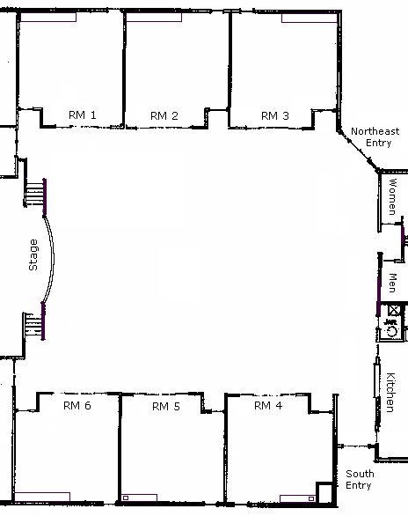

Room Divider

(3 available)

Revised 1/12/14 by Robert Renwick

Chair

Chairs per table

**T**

3' X 20" table

(6 available)

6' X 18" table

(34 available)

6' Round Table

(30 available)

6' X 30" table

(27 available)

Trash Can

(8 available)

6' Round Table

(with chairs)

)

6' Round Table

(30 available)

6' X 30" table

(18 available)

6' X 18" table

(34 available)